PROBLEMSTATEMENTS

DomainName:InternetOfThings(IoT)

Project Name:Smart Solution For Railways

Team ID:PNT2022TMID49411

**Example:PS-1**

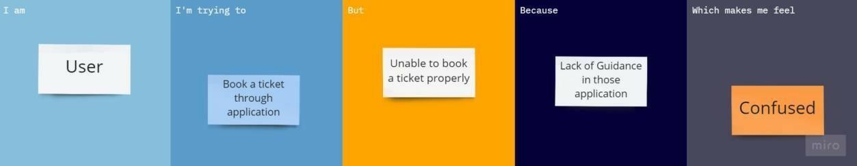

**PS–2**

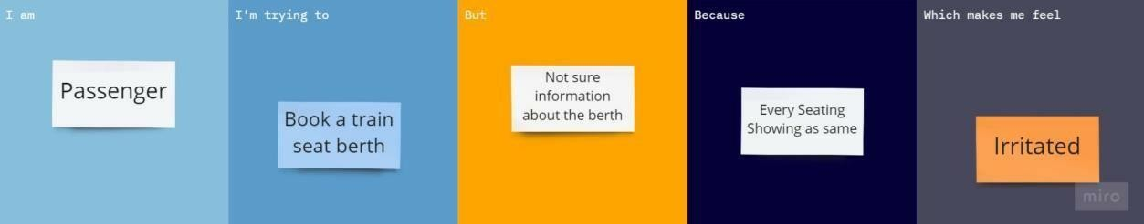

**PS–3**

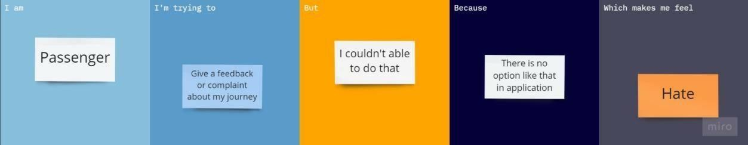

**PS–4**

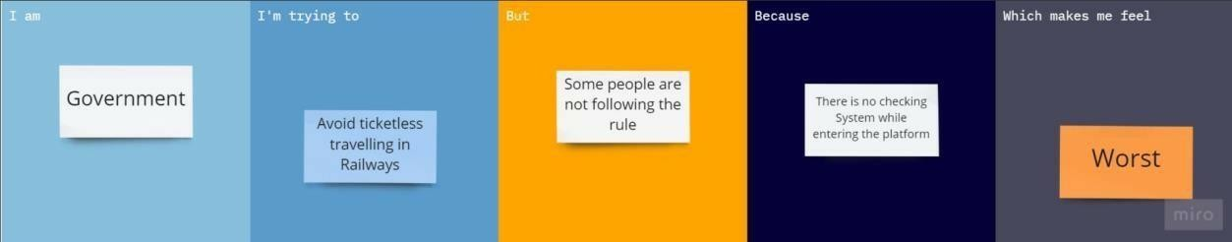

|  |  |  |  |  |  |
| --- | --- | --- | --- | --- | --- |
| **ProblemStatement(PS)** | **I am(Customer)** | **I’m tryingto** | **But** | **Because** | **Whichmakes mefeel** |
| PS-1 | User | Book a ticketthroughapplication | Unable tobook ticketproperly | Lack ofGuidance inthoseapplication | Cofused |
| PS–2 | Passenger | Book a trainSeatBerth | Not Sureinformationabout theberth | Evert seatingshowing assame | Irritated |
| PS–3 | Passenger | Give afeedback orcomplaintabout myjourney | Icouldn’table to dothat | There is nooption likethat inapplication | Hate |
| PS–4 | Government | AvoidTicketlesstraveling inRailways | Some peopleare notfollowing therule | There is nocheckingwhileentering theplatform | Worst |

Reference:<https://miro.com/templates/customer-problem-statement/>